**DAILY ONLINE ACTIVITIES SUMMARY**

|  |  |  |  |  |  |  |  |  |
| --- | --- | --- | --- | --- | --- | --- | --- | --- |
| **Date:** | **15/07/2020** | | | | | **Name:** | **Spoorthy Balaji** | |
| **Sem & Sec** | **6th & B** | | | | | **USN:** | **4al17cs098** | |
| **Online Test Summary** | | | | | | | | |
| **Subject** | | **OR IA Module 1**  **OR Assignment 3 QUIZ** | | | | | | |
| **Max. Marks** | | **OR IA: 30**  **OR Assignment: 30** | | **Score** | | | **0R IA: -**  **OR Assignment: 18** | |
| **Certification Course Summary** | | | | | | | | |
| **Course** | **Introduction to HTML5** | | | | | | | |
| **Certificate Provider** | | | **Coursera** | | **Duration** | | | **1month** |
| **Coding Challenges** | | | | | | | | |
| **Problem Statement**: **Python Program for Sieve of Eratosthenes** | | | | | | | | |
| **Status: Solved** | | | | | | | | |
| **Uploaded the report in Github** | | | | | **yes** | | | |
| **If yes Repository name** | | | | | <https://github.com/spoorthybalaji/Daily_Status> | | | |
| **Uploaded the report in slack** | | | | | **yes** | | | |

**OR Assignment Quiz**

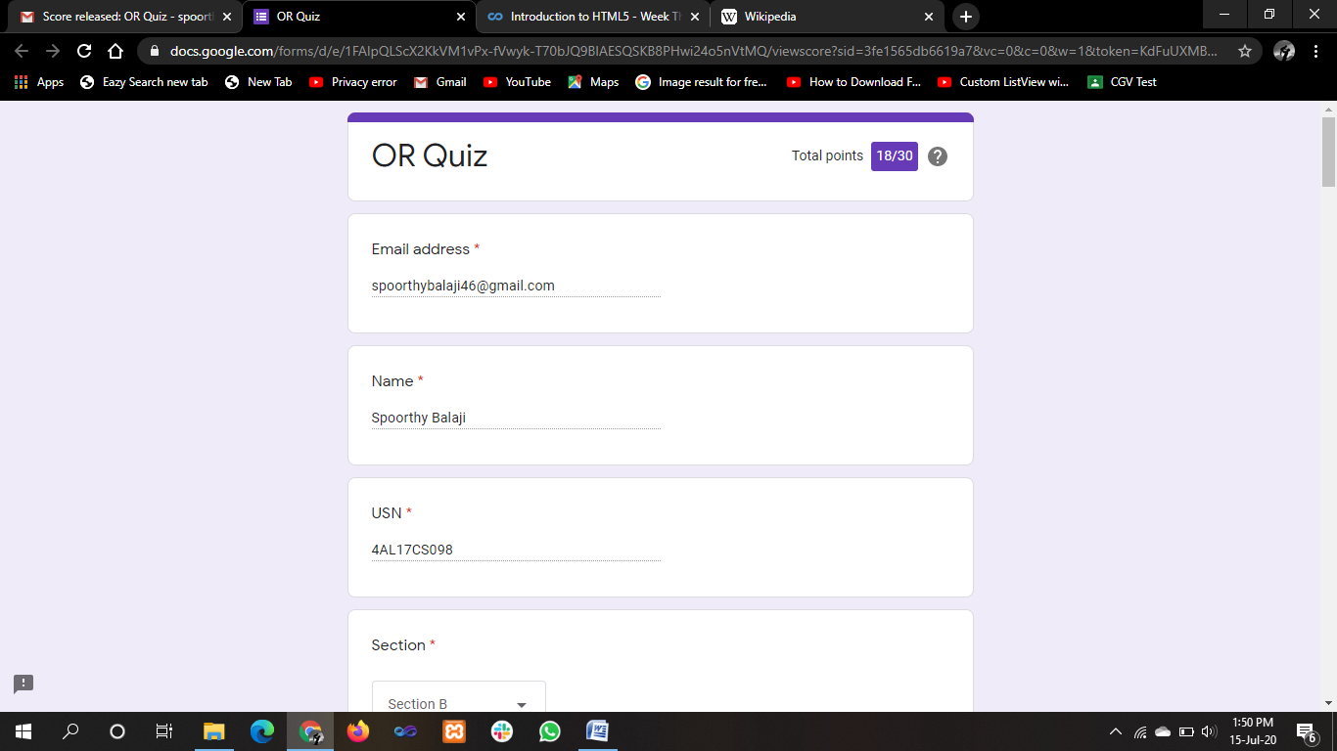

**ONLINE COURSE**

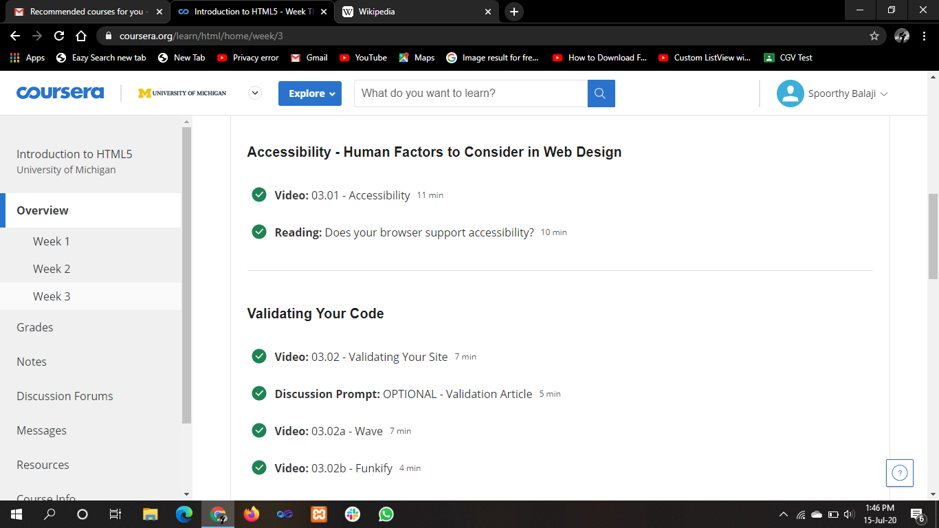

**ONLINE CODING**

**Python Program for Sieve of Eratosthenes**

def SieveOfEratosthenes(n):

prime = [True for i in range(n + 1)]

p = 2

while (p * p <= n):

if (prime[p] == True):

for i in range(p * 2, n + 1, p):

prime[i] = False

p += 1

prime[0]= False

prime[1]= False

for p in range(n + 1):

if prime[p]:

print(p),

if __name__=='__main__':

n = 30

print("Following are the prime numbers smaller than or equal to"),

n

SieveOfEratosthenes(n)

